**How to prevent method of parent class being overridden by the child class**

We use the final keyword

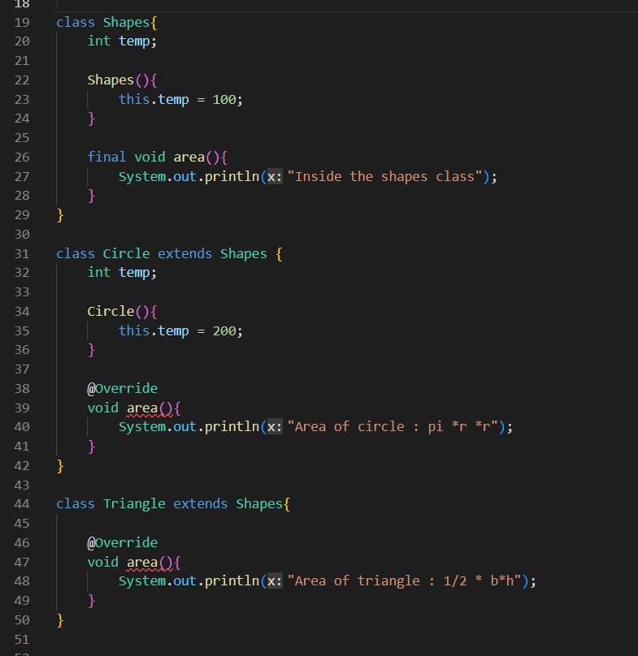

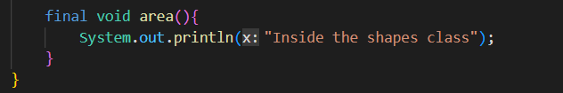

On using the final keyword in the area( ) method the compiler will understand that this is the final method, there will exist be no other method by this name, so java won’t allow the overriding of the same method

**Late Binding**

Here if the final keyword was not used then

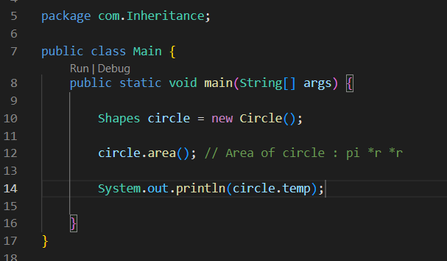

Here which method to execute i.e either area( ) of the parent class or the area( ) of the child class would be determined at the run time, so called late binding

**Early binding**

Here on using the final keyword, java will forbid the overriding of the area( ) method in the child class, so it’s 100% percent certain that area( ) method of the parent class will run. So which method is to be executed is determined very early at the compilation so known as early binding